吉林大学

DB2实验报告

班级：552410
姓名：柳湛博
学号：55241019

姓名 | 柳湛博 | 学号 | 55241019
实验项目 | 5. Backup and recovery
实验性质 | □演示性实验 □验证性实验  操作性实验 □综合性实验
实验地点 | A108 | 机器编号 | 10
指导教师 | 刘雪洁 | 实验时间 | 2026年 9月 28日 20时 4分
一、实验综述
1. 实验目的及要求
This exercise is an online lab where the database MUSICDB will be used for backup and recovery. During this lab the students will prepare the database for archival logging, create a backup and restore and recover the database to the current as well as to a prior point in time.
At the end of the lab, students should be able to:
• Create backup images of a database and of table spaces
• Restore a database from a backup image
• Roll forward a database or table spaces to perform full recovery
• Perform actions to reactivate databases in exception states
2. 实验设备、软件
PC, windows XP Professional, DB2 9 Express-c
二、实验过程（实验步骤、记录、数据、分析）
Section 1 - Determining Log Configurations
1. Before beginning this lab, you need to make sure some of your database configuration parameters are set to the values required by this lab. Do this by running the script recovrst.
Show your work below by printing screen.
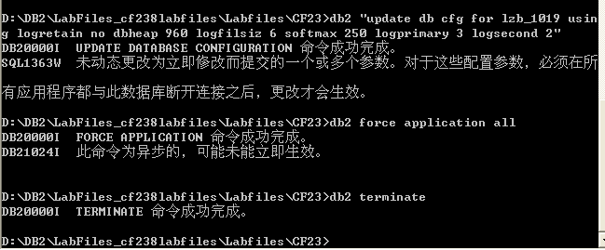

2. Connect to MUSICDB to activate the database.
3. Examine your db cfg file for MUSICDB.
How large are the log files? Is this amount in pages or bytes?
Show your work below by printing screen and answer the question.
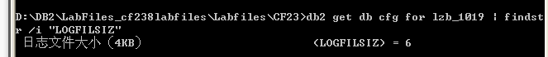
6
Pages

4. How many primary log files will be allocated? When will these files be allocated?

3
在数据库被激活时（例如第一次连接到该数据库时）进行分配。

5. How many secondary log files will be allocated? When will these files be allocated?
2 (由 `LOGSECOND` 参数决定)。
当主日志文件（Primary log files）写满，需要更多日志空间时动态分配。

6. For which type of logging is your database currently configured (log retention or circular)? What parameters provide this information?

循环日志（Circular logging）。

Log retain for recovery status (LOGRETAIN) = OFF` 且 `User exit for logging status (USEREXIT) = OFF`。

7. Which types of recovery are supported by this type of logging — Crash, Version, or Roll forward?

崩溃恢复（Crash recovery）和版本恢复（Version recovery，即从脱机备份中恢复整个数据库）。不支持前滚恢复（Roll forward）。

8. Where do the log files reside?

根据 `db cfg` 中的 `Path to log files` 参数

在 `D:\DB2\NODE0000\SQL00001\SQLOGDIR\`

9. Assume the database manager was active. A short interruption of power made it necessary to perform a crash recovery. Will manual intervention be required to cause this crash recovery? What configuration parameter relates to this issue?
NO
Auto restart enabled (AUTORESTART) = ON`。
是否需要人工干预：不需要（No manual intervention is required）。
相关配置参数：`AUTORESTART`（自动重新启动标志）。当该参数设定为 `ON` 时，一旦发生意外断电重启，当应用程序下次连接数据库时，DB2 引擎将全自动检测并静默完成崩溃恢复，使数据库重回一致性状态。

10. From your Command Window session, change your current directory to the log path, but exclude the SQLOGDIR directory from your command.
Note: Do NOT EDIT these files!
Show your work below by printing screen.
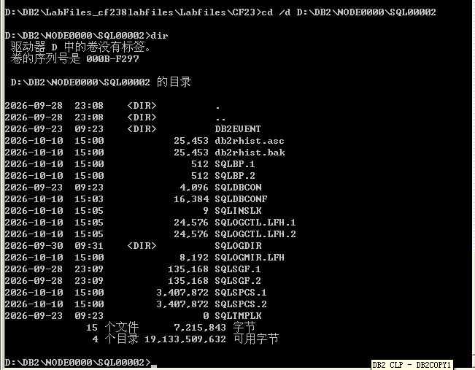

11. Determine the contents of this directory.
What are T0000000, T0000001, T0000002?
它们是当前数据库内部表空间（Table Spaces）的数据容器或元数据控制目录/文件。在 DB2 底层架构中，每个以 `T` 开头的对象编号对应数据库中特定表空间 ID（例如系统编目表空间、临时表空间或系统管理表空间的内部存储句柄）。
12. Is it appropriate to keep the log files in the same path? (Consider the type of recovery currently supported in your answer.)
不合理。为了更好的性能（避免 I/O 争用）和在磁盘发生故障时进行恢复，日志文件通常应当与数据库数据文件放置在不同的物理磁盘上。

13. Now, list the contents of SQLOGDIR.
Show your work below by printing screen.
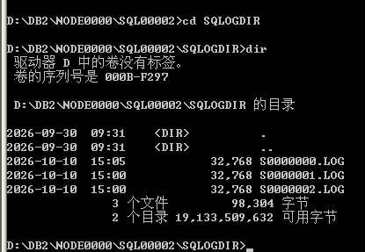

14. How many log files are in this directory? Does this match what you expected considering your configuration file? Why or why not?

3个
是的，匹配。因为参数 `LOGPRIMARY` 被设置为 3，且数据库已经激活，所以预先分配了 3 个主日志文件。

15. Increase the quantity in the STOCK table by 1 but do not commit the update. If you are not certain how to turn off auto-commit, check the solutions.
Show your work below by printing screen.
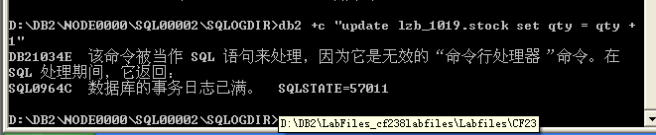

16. If you encounter an error, go to the next question. If you did NOT encounter any error, decrease the quantity in the STOCK table by 1.
Show your work below by printing screen.

17. What did you observe? What was the SQL code you received?
更新操作被系统拒绝，提示事务日志已满；
收到的 SQL 代码：SQL0964C（SQLSTATE=57011）。

18. Issue a command to retrieve help on the SQL code. Why did the statement fail?
Show your work below by printing screen.

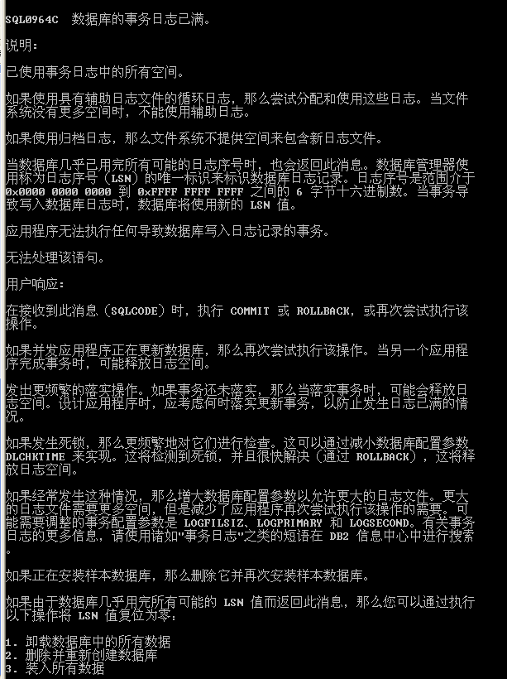

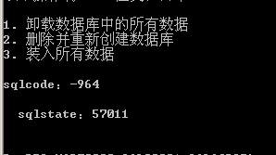

19. Since the unit of work could not complete successfully, issue a rollback.
Show your work below by printing screen.

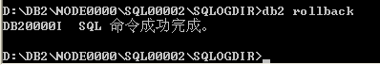

20. From your telnet session, determine the number of log files allocated at this point. How many are there?

5 个。

21. What accounts for the additional files?

当 3 个主日志文件写满后，由于事务没有提交，数据库管理器根据 `LOGSECOND` 参数分配了 2 个额外的辅助日志文件。

22. Change to your home directory in your Command window.

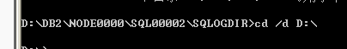

23. From your telnet session, create a directory that will contain backups of your database: mkdir restore



Section 2 - Backup/Restore Support with Circular Logging
1. Connect to your musicdb database from the new command window.
Show your work below by printing screen.
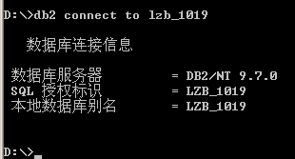

2. Attempt to perform an online backup of your MUSICDB database to the directory of C:\restore. Were you successful in trying to specify an online backup? Explain why or why not.
Show your work below by printing screen and answer the question.
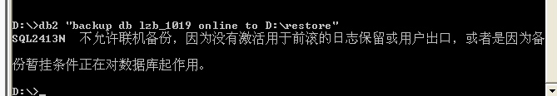

无法成功执行联机备份。原因分析：联机备份（Online Backup）允许用户在备份期间并发读写数据库，这意味着备份映像必须结合备份期间生成的事务日志才能恢复到一致性状态。因此 DB2 强制规定联机备份必须在归档日志（支持前滚恢复）模式下运行。当前数据库配置为循环日志（`LOGRETAIN=OFF`），不支持前滚恢复，因而直接拒绝联机备份。

3. Attempt to perform an offline backup instead.
Show your work below by printing screen.
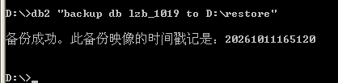

4. Did the backup complete successfully? What did the message say?
是的，备份直接成功了。提示信息为：“备份成功。此备份映像的时间戳记是: 20261011165120”。

5. In order to take an offline backup, do you think that exclusive use of the database is required? Who is currently connected to the database?
是的，脱机备份需要独占访问。因为我当前没有任何应用连接到该数据库，所以获得了独占访问权并备份成功。

6. Resolve the apparent problem by forcing all applications to end.
Show your work below by printing screen.
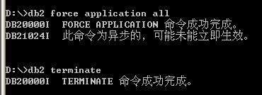

7. Now try your backup again.
Show your work below by printing screen.
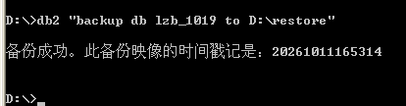

8. Was the backup successful this time?
是的

9. The timestamp for a backup image is necessary for restore if you are using the RESTORE command rather than the GUI DB2 Control Center, and multiple images reside in a given source.
When the backup is targeted to disk, the name of the file itself will reflect the timestamp. When tape or TSM managed devices are used, the header in the backup image will contain this information.
10. Look at the backup information through the LIST BACKUP command. Remember that you have a previous backup from an early lab (LOAD lab). Issue the list backup command with the ALL keyword.
Show your work below by printing screen.
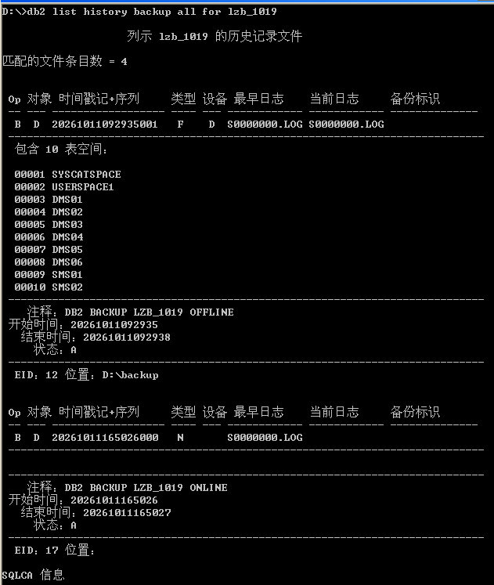
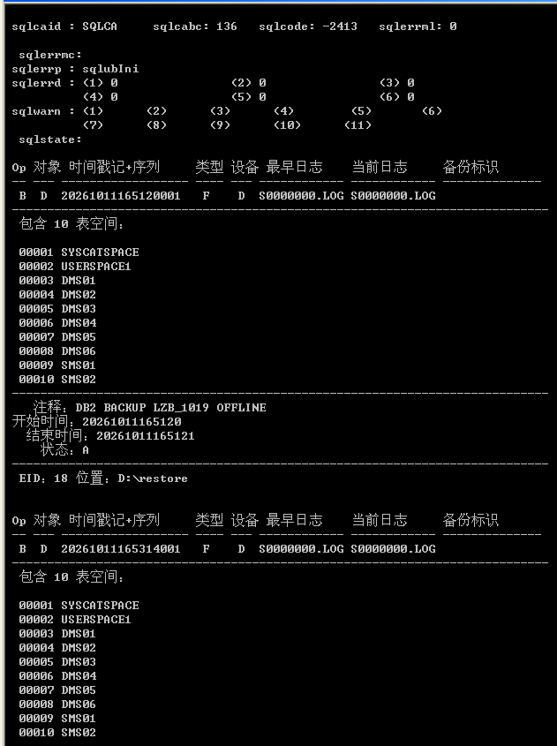
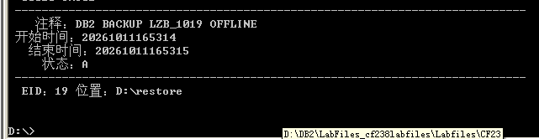

11. Is the timestamp available as part of this information?
是的。

12. Record the start timestamp of the backup.
20261011165315

13. How many table spaces are included in this backup?
10

14. Instead of using the keyword ALL, it is possible to restrict the output of the LIST BACKUP command via a timestamp specification or by object name specification.
Issue a request to get just the backups for today.
You may wish to request online help for this command.
Show your work below by printing screen.
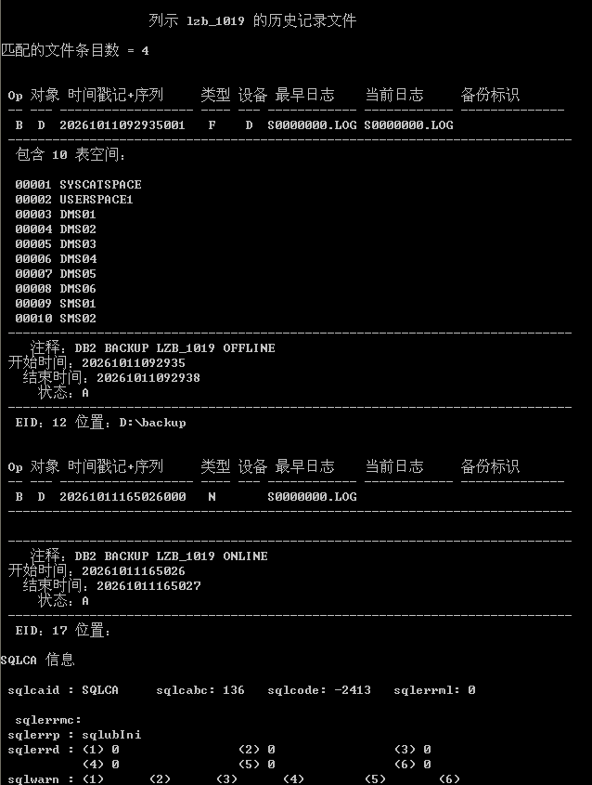

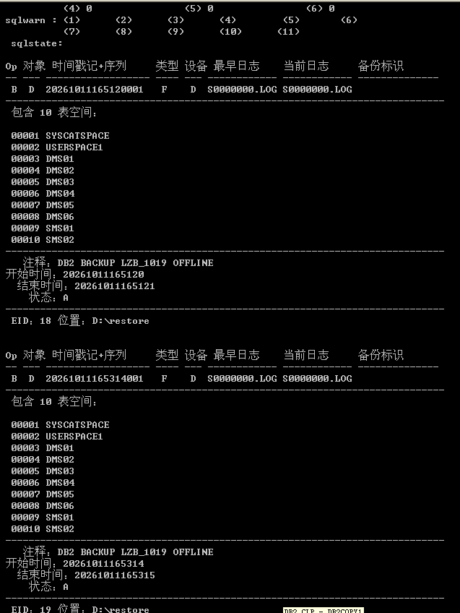

15. The history information regarding backups is maintained by the database manager and can become extensive if it is never removed. Use the ? command to invoke the online help facility to identify a command that can be used to manage the amount of history information retained. Write the name of the command you believe would give you the capability to eliminate old history information.
Show your work below by printing screen.


PRUNE HISTORY

16. From your Command Window, examine the file naming convention used for your backup.
Show your work below by printing screen.
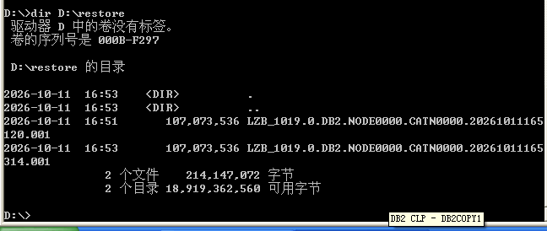

17. The backup image reflects the same data that is currently in your MUSICDB database since you have not issued any SQL to change data since the backup was taken. Select the artist's name and album titles for artist number (ARTNO) 77.
Show your work below by printing screen.
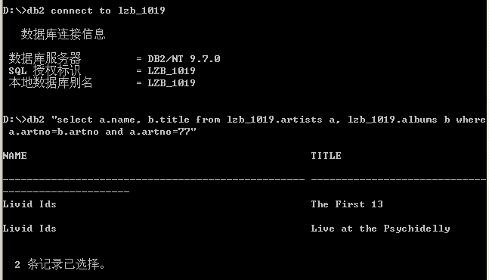

18. Change the name of the artist 77 to “Melanie and the Mechanics” and the album title of ITEMNO 261 to “Unmaterial Girl”.
Show your work below by printing screen.
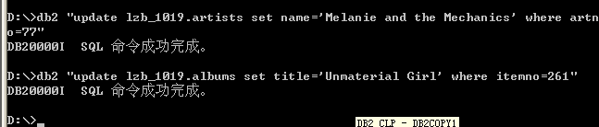

19. Execute a join between ARTISTS and ALBUMS for ARTNO 77 and document the data as it now appears. This reflects a change that occurred after your backup.
Show your work below by printing screen.
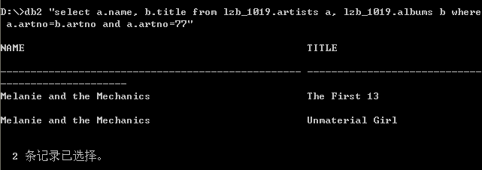

20. Assume the disk containing the MUSICDB database failed. You now have the task to restore the backup image that was made.
Show your work below by printing screen.
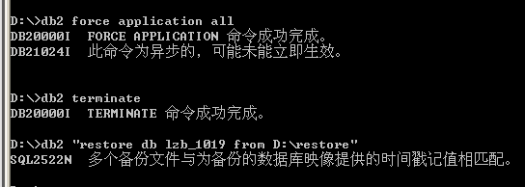

21. First make sure there are no applications are connected to the database.
Show your work below by printing screen.

22. Restore the database from the C:\restore directory.
Show your work below by printing screen.

23. Connect to MUSICDB and execute the join between ARTISTS and ALBUMS for ARTNO 77.
Show your work below by printing screen.
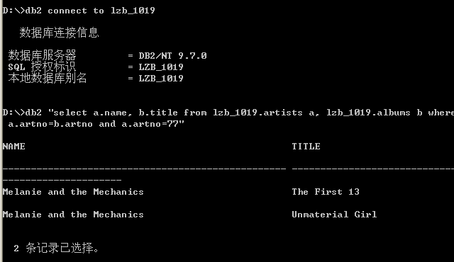

24. Does the data reflect the updates made, or is the original data restored?
显示的是备份时的原始数据，我们在备份之后做的修改已经丢失。

25. Assume that you are not in a lab environment. You made your backup three days ago and thousands of transactions have since occurred. Would your current recovery strategy be acceptable?
不可接受。因为自备份之后发生的所有成千上万笔事务修改都会在恢复时完全丢失，且无法通过前滚日志找回这些修改记录。

Section 3 - Backup/Restore Support with Archive Logging
1. Update the database configuration file to indicate that log retention logging is to be used (recovery).
Show your work below by printing screen.
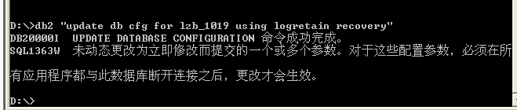

2. Some changes to the db cfg file (including changes to LOGRETAIN) do not take affect until the database is deactivated and becomes active again. Since the database was activated by the first user connect, all applications must end to deactivate the database. Try issuing a DB2 terminate command.
Show your work below by printing screen.
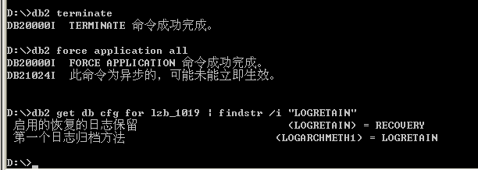
3. To find out for sure if log retention logging is in effect now, look at the Log retain status indicator in the db cfg.
Show your work below by printing screen.

4. Did the terminate command change anything concerning the parameters?
LOGRETAIN` 的状态可能仍未完全生效，因为可能还有其他连接未断开。

5. Try forcing all applications off the database.
Show your work below by printing screen.
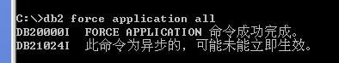

6. Did the Log retain status indicator value change to RECOVERY?
Show your work below by printing screen and answer the question
是的，完全断开连接后配置生效，变成了 RECOVERY。

7. Connect to musicdb database. Was the connection successful? What does the SQL message indicate? Why does the database manager require a new backup?
Show your work below by printing screen and answer the question
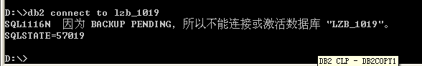

消息说明：数据库当前处于 备份暂挂（Backup Pending） 保护状态。
当数据库从循环日志切换为归档日志后，日志机制发生了本质蜕变。DB2 必须强制要求管理员做一次全量脱机基准备份（Baseline Backup），以此作为未来所有增量日志前滚重放的“原点”。在获得该基线前，数据库严禁读写。
8. Did the attempt to connect to the database cause log retention to be activated?
Show your work below by printing screen and answer the question

是的，更改配置并完全断开连接后，数据库激活了归档日志模式，并立即将其置于 backup pending 状态。

9. Create an offline backup of your database and record the timestamp.
Show your work below by printing screen and answer the question.
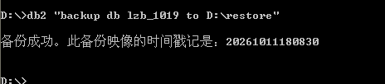

10. Complete a series of SQL statements to change data in the ARTISTS table and record points in time associated with these changes.
a.Change the name of ARTNO 77 to "Melanie and the Mechanics".
b.Record the time.
c.Change the name of ARTNO 77 to "Bill Pellett and the Comets".
d.Record the time.
Show your work below by printing screen.
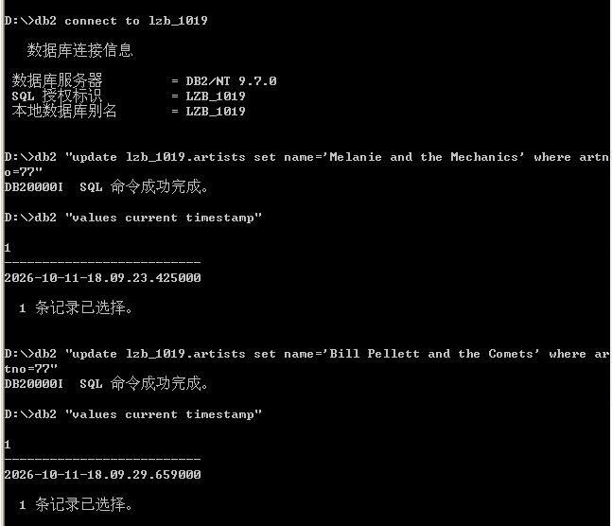

11. View the db cfg again. What is the value of the first active log file?
Show your work below by printing screen and answer the question.
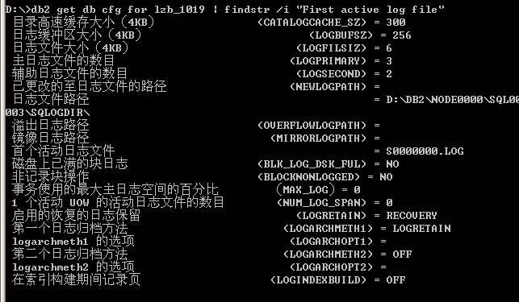

12. Restore your backup.
Show your work below by printing screen.
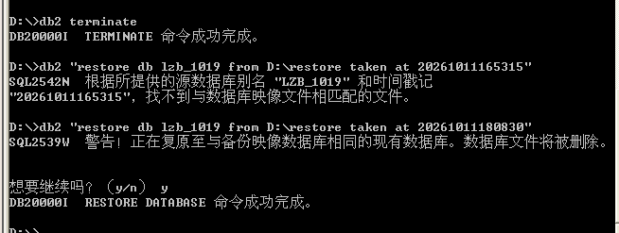

13. Did the restore fail?

没有

14. If the directory containing the backup image you wish to restore contains other images for the same database alias, you must specify which image to use with the TAKEN AT option on the restore command. If the previous restore failed, issue the restore command indicating which backup you wish to be restored via the TAKEN AT option.
Show your work below by printing screen.

15. Earlier in this lab, you attempted to connect to the database when it was in a backup pending status. You received a message during the connect to indicate this status. There is another method to determine the state of the database. Examine the db cfg again. Check the Recovery Status values.
Show your work below by printing screen.
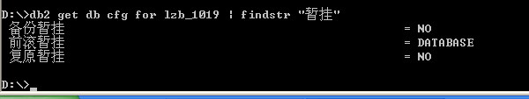

16. Is the database in any pending state?

是的，数据库当前正处于“前滚暂挂（Rollforward pending）”状态，其状态值为 DATABASE（全数据库级前滚暂挂）。

17. This state will occur if a restore is done to an online backup or a restore is done to an offline backup without specifying the WITHOUT ROLLING FORWARD phrase.
Show your work below by printing screen.
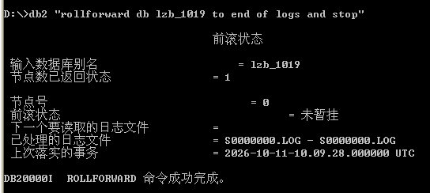

18. Check the db cfg again to see if the Rollforward pending status was removed. Was it?
Show your work below by printing screen and answer the question.
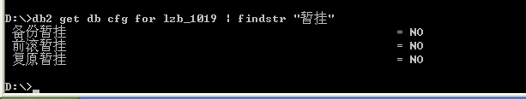

是的

19. Connect to MUSICDB database.
Check the contents of the row you updated earlier (ARTNO 77).
Show your work below by printing screen.
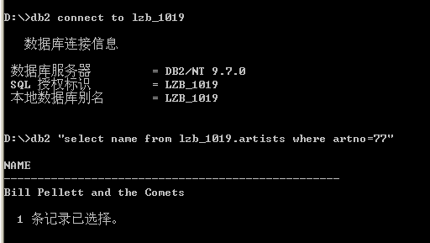

20. What is the value of the name returned? Why?
Bill Pellett and the Comets`。
因为我们启用了归档日志，并且进行了前滚恢复（Rollforward）操作。前滚操作读取了事务日志并重播了自备份以来的所有更改操作，从而恢复到了系统故障前的最新状态。

21. Even though the database manager is configured for roll forward recovery, you are not required to apply log records.
Restore the database backup and indicate that you do not want to roll forward.
Show your work below by printing screen.
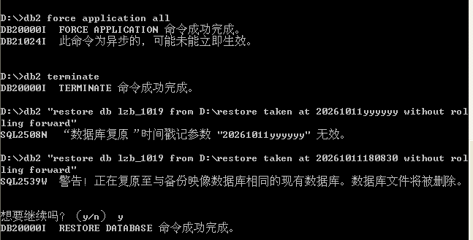

22. Check the pending status of your database by looking at the db cfg.
Is the database in any pending state? Did the value returned to you match what you expected?
Show your work below by printing screen.
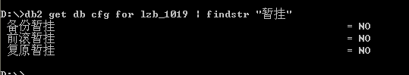
* RESTORE 成功完成；
* `ROLLFWD_PEND = NO`（没有处于任何暂挂状态，数据库立即可用）。
23. Connect to MUSICDB database.
Issue a SELECT statement against the artists row that was previously updated (ARTNO 77).
Did the value returned to you match what you expected?
Show your work below by printing screen and answer the question.
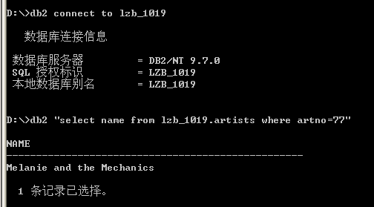

是的。返回的是备份最初是的旧名称。这也证实了，如果在恢复时明确指示不前滚，那么记录在日志中的所有后续修改操作（Melanie 和 Bill）都不会被应用。

Section 4 - Resetting the Environment
1. Execute the cleanup script clrec.
Show your work below by printing screen.

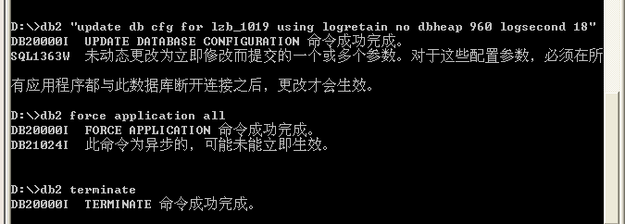

2. Examine your db cfg and verify that your database is now configured for circular logging.
Show your work below by printing screen.


